First create a security groups:

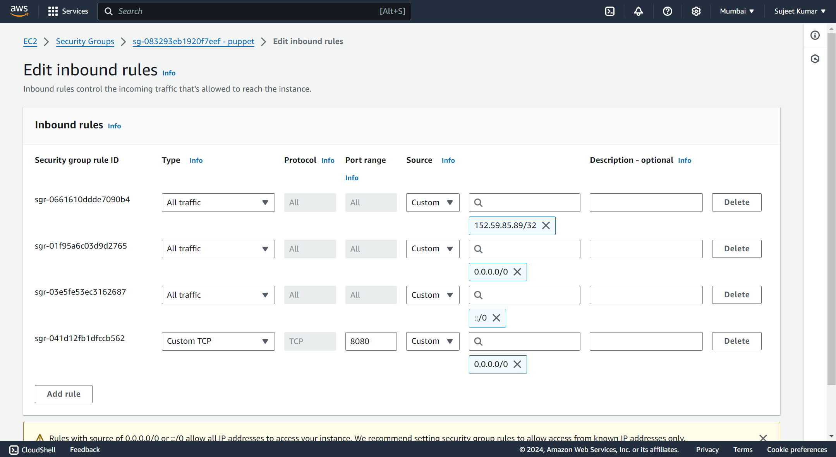

Create 3 Ec2 instance of AMAZON Linux machine

1 Ansible Master

2 Ansible slave1

3 Ansible slave2

And choose existing security groups

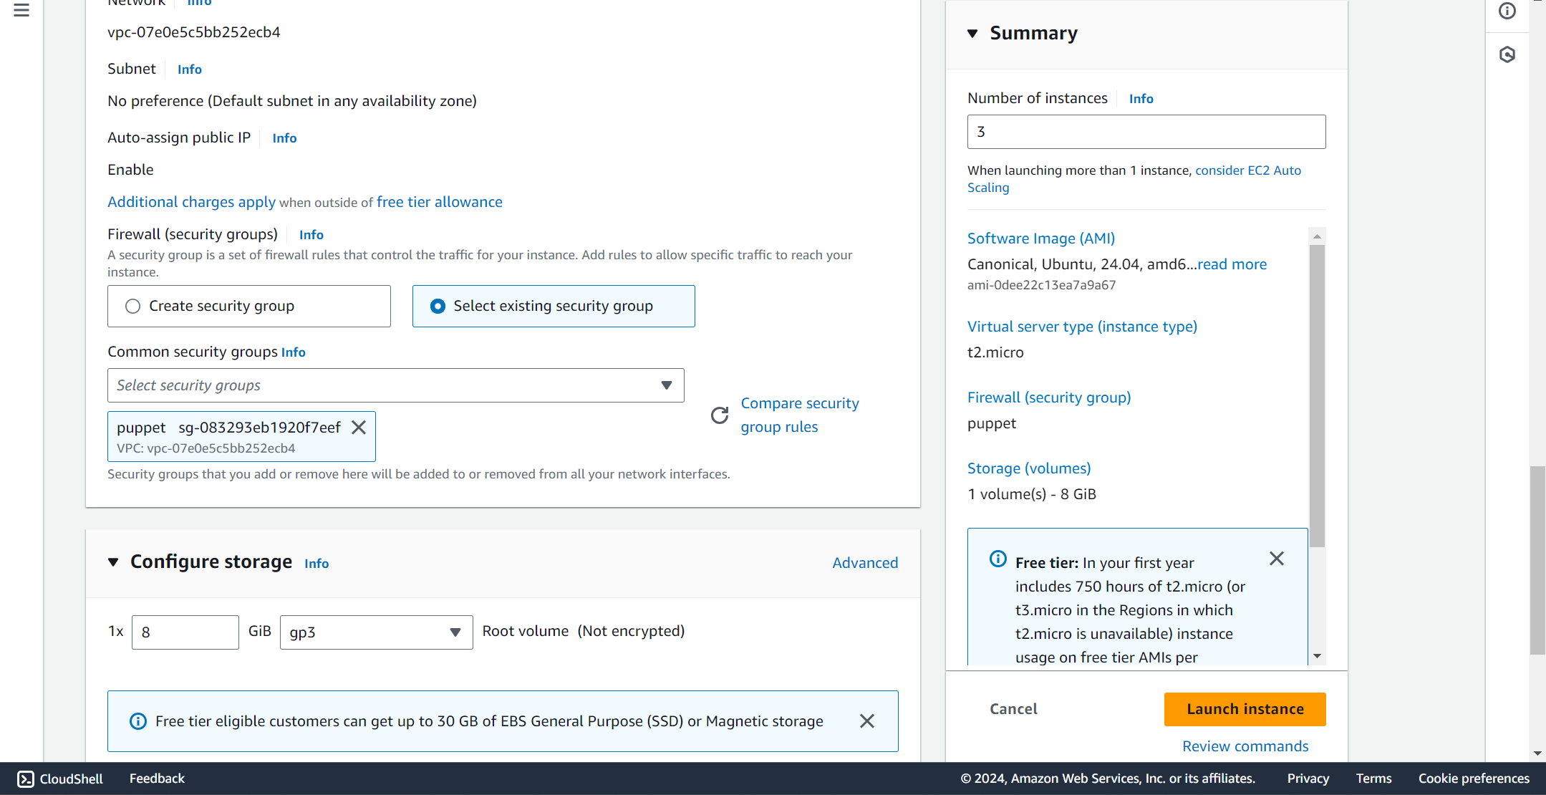



sudo yum update -y

sudo su –

useradd ansadmin

passwd ansadmin

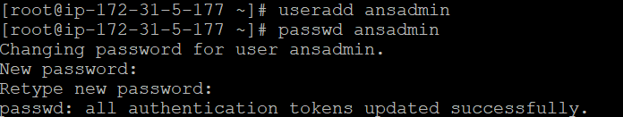

vi /etc/sudoers

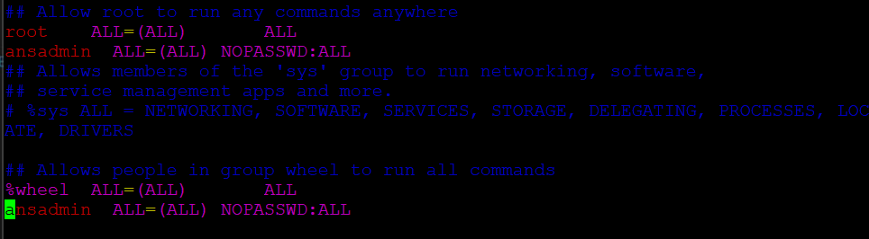

ansadmin ALL=(ALL) NOPASSWD:ALL

Then :wq!

vi /etc/ssh/sshd_config



Change to yes



And in the above of this code  
uncomment the permitRootLogin yes



Then :wq!

systemctl restart sshd

Node 1

sudo su -u

Clear

useradd ansadmin

passwd ansadmin

vi /etc/sudoers

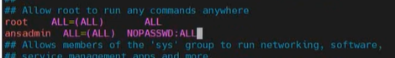



:wq!

vi /etc/ssh/sshd_config

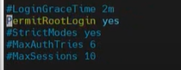

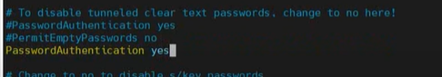

:wq!

systemctl restart sshd

Node 2

Sudo su –

useradd ansadmin

passwd ansadmin

vi /etc/sudoers

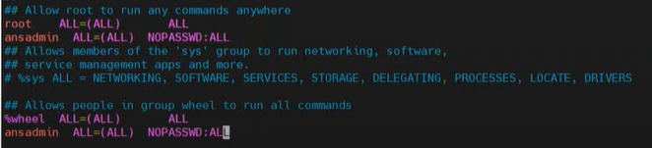

:wq!

vi /etc/ssh/sshd_config





:wq!

systemctl restart sshd

main

su – ansadmin

sudo yum update -y

ssh-keygen

this will generate the key

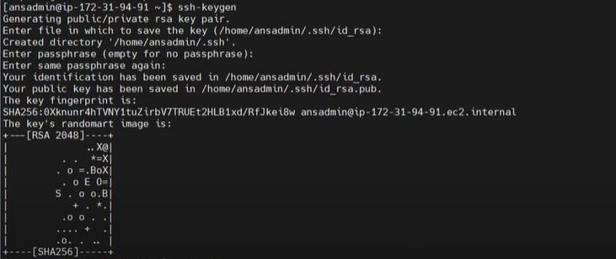

cd .ssh/

ls -ltr



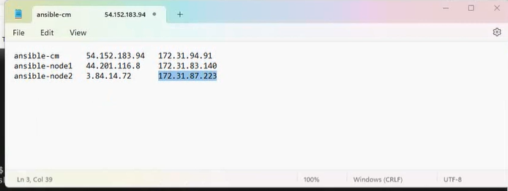

ssh-copy-id ansadmin@(private ip of node 1)

yes

(enter your password)

ssh-copy-id ansadmin@(private ip of node2)

Yes

(Enter your password)

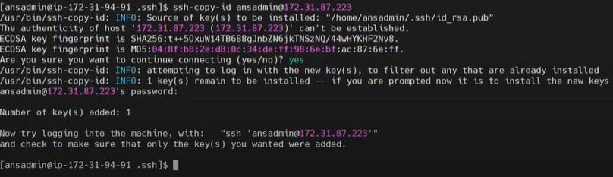

ssh ansadmin@(private ip of node2)

You will enter in the node2 server

Type exit

Clear

sudo yum install ansible -y

ansible –version(--)

cd /etc/ansible/

ls -l

sudo chown -R ansadmin:ansadmin *

ls -l

sudo touch /etc/ansible/hosts

sudo chmod 666 /etc/ansible/hosts

sudo vi /etc/ansible/hosts

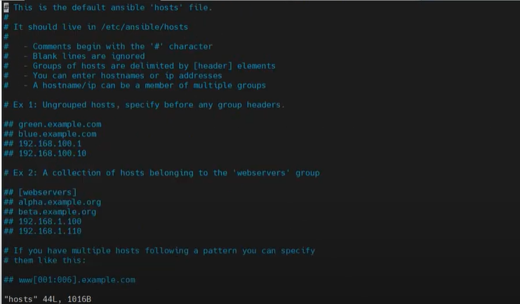

At bottom add these lines

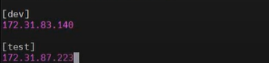

Private ip of node1 (dev)

Private ip of node2 (test)

:wq!

ansible all -m ping

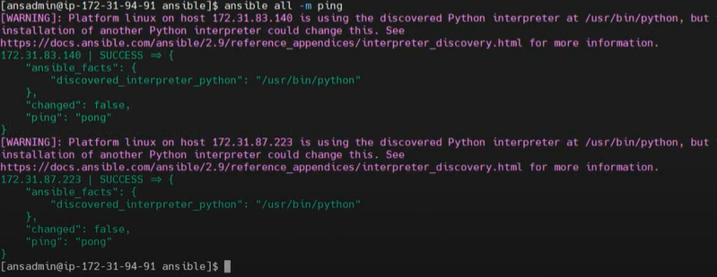

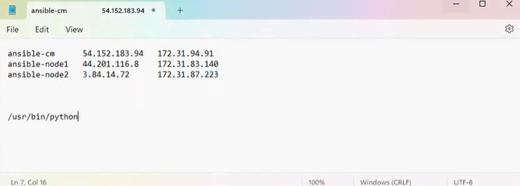

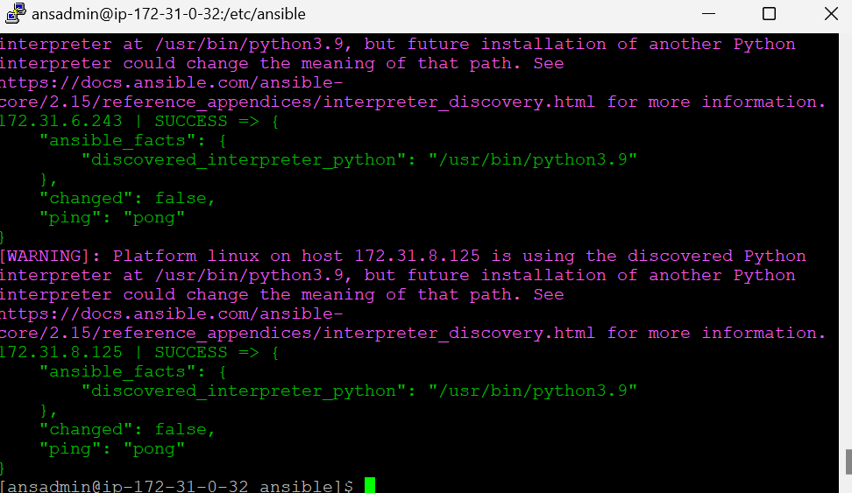

Goto to this site  
docs.ansible.com/ansible/2.9/reference_appendices/interpreter_discovery.html

Add the interpreter to python

sudo touch /etc/ansible/ansible.cfg

sudo chmod 666 /etc/ansible/ansible.cfg

sudo vi /etc/ansible/ansible.cfg

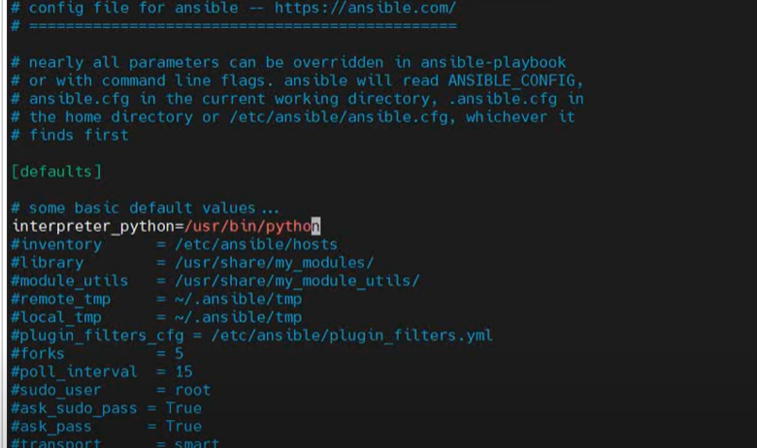

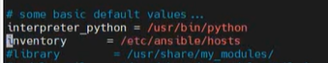

interpreter_python = /usr/bin/python

inventory = /etc/ansible/hosts

and uncomment the inventory

:wq!

ansible all -m ping

sudo touch chinna

ls -l

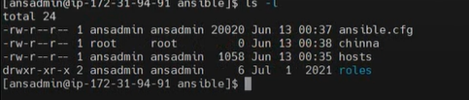

ansible all -I hosts -m copy -a “src=chinna dest=/home/ansadmin/”

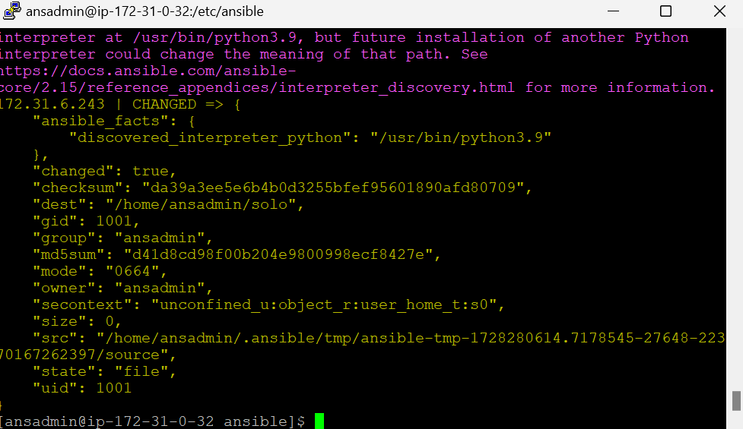

Node 1

Sudo su – ansadmin

ls -l

node 2

sudo su – ansadmin

ls -l

main server

vi first.yml

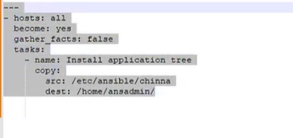

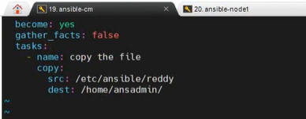

:q!

sudo touch reddy

sudo vi first.yml

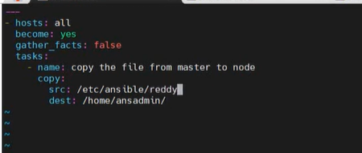

:wq!

ansible-playbook first.yml --syntax-check

ansible-playbook first.yml --check

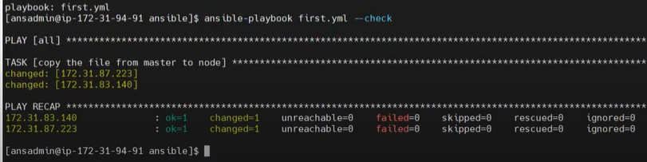

ansible-playbook first.yml

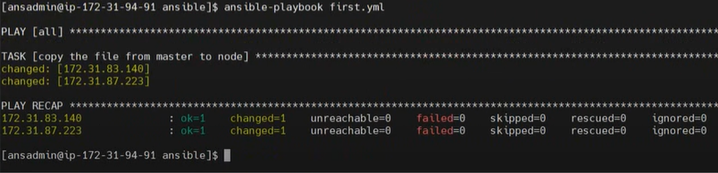

Node 1

ls -l

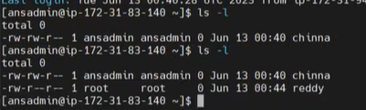

Node 2

ls -l

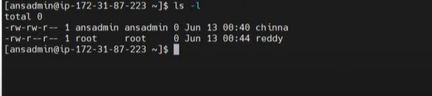

Main

sudo vi reddy

Good morning

:wq!

ansible-playbook first.yml -vvv

node 1

cat reddy



Node 2

cat reddy